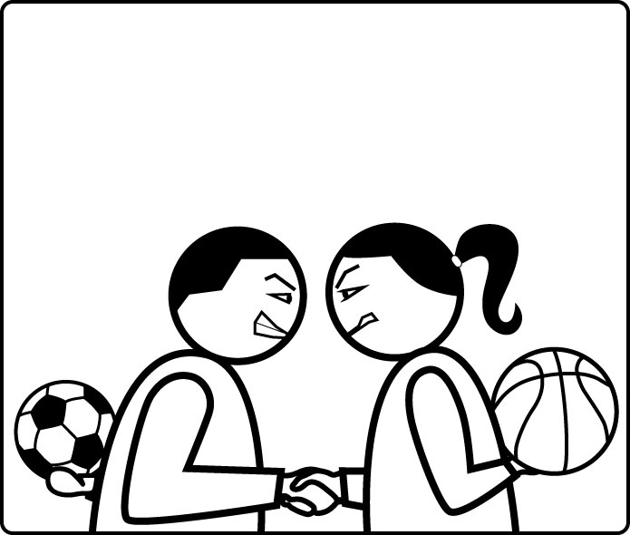

SOCIAL SPORTS
–
Play Your Friends !

Technical Design Document

Design by Frédéric Fourcade
for Facebook, on Web and Mobile plateform

Introduction
This document specifies the global architecture of the game. Since the game is mainly a server-side game, most of the work will be done in PHP. The choice of doing it in PHP is mostly for educational reasons. The game doesn't need a socket server (it would if the matches were resolved with active interactions from the two users), so a web-server will be enough (it's cheaper, there are many free frameworks, and a great community). And as web-server technology, PHP is a real standard.
Regarding the DB engine, we will use MySQL for the basic features of the game (managers, players, teams), as these are simple tables with simple relationships. On the other hand, for the bonus features, where users will have specific data of various size and format, we will choose go to MongoDB, which is a JSON based DB engine, and allows a great freedom of format, where MySQL tables need to be specified upstream.
To run all this, there are many free frameworks available, and my choice goes at Symfony2, which is a very complete and easy framework. A Facebook bundle is available to connect and get facebook data. MySQL is natively handled by Symfony, and we can find a MongoDB driver for PHP and make it work in Symfony with the right bundle.
On client-side, we will go for Flash, as it is a standard, easy, free and complete solution. It will also allow us to easily port the game to mobile in the future. In order to achieve this, we will use Starling as framework, with vectorized graphics. The Facebook connection will be done using the Actionscript-Facebook-API (http://code.google.com/p/facebook-actionscript-api/) and maybe JS when AS API is not enough. Communication with server will be done using AMF, therefore a AMF bundle will be needed for the Symfony fwk.
This document will detail the PHP class organisation (in the Symfony framework), the MySQL diagram of the DB (MongoDB is not needed in V0).

Table des matières
Table des matières
1Introduction 2
2Table des matières 3
3List of services 4
4PHP architecture 5

List of services
Here is the list of services that will be called by the client depending on the user's actions.

1. GetManagerProfile
This is the request made to get a complete manager's profile. If the requested manager is the user, it returns the following data:
- Firstname, lastname and nickname
- Picture url
- List of unlocked players objects, with the following data:
  - Firstname, lastname and nickname
  - Picture url
  - List of attributes' values in a standard array (the attributes are sorted so that each index is always associated to the same attribute (cf. config file))
  - Level
- List of locked players, with the following data:
  - Firstname, lastname and nickname
  - Level
- A list of the different teams of the manager (one per sport), indexed by String. Each list is a standard array, where each index is a defined position on the field (cf. Config file). Each entry has the following data:
  - Player's facebook id
- [(N/A in V0) XP, coins]

2. GetPlayingFriends
This request returns the complete list of the user's facebook friends that are actually playing the game. It returns the follwonig data:
- Firstname, lastname and nickname
- Picture url
- A list of the different teams of the manager (one per sport), indexed by String. Each list is a standard array, where each index is a defined position on the field (cf. Config file). Each entry has the following data:
  - Player's facebook id
- [(N/A in V0) XP]

3. GetNonPlayingFriends
This request returns a partial list of the user's facebook friends that do not yet play the game. We could make this choice based on these friends' activity in facebook (do they play other games ?), but at first we will just randomly pick a number of the user's friends. This request returns the following data:
- Firstname and lastname
- Picture url

4. GetRandomOpponents
This request returns a specified number of opponents, randomly chosen among the game database. It returns the following data:
- A list of managers in a standard array. Each entry has the following data:
  - Firstname, lastname and nickname
  - Picture url
  - A list of the different teams of the manager (one per sport), indexed by String. Each list is a standard array, where each index is a defined position on the field (cf. Config file). Each entry has the following data:
    - Firstname, lastname and nickname
    - Level
  - [(N/A in V0) XP]

5. GetConfigData
This request returns all the static data that are customizable (therefore, cannot be included in the code directly). The response shall include the following data:
- Everything listed in Chapter 9. “Customizable Parameters” of the GDD.
- [(N/A in V0) The manager's levels and their correspondance with XP threshold]

6. PlayMatch
This request is the one sent by the client when the user has started a match against a chosen opponent. This request shall be rerouted to the MatchEngine on server-side, and, once the match simulation is completed, shall return the following data:
- Final score
- Relevant actions made during the match (like goal scorers in a football match simulation)
- Players' data, which will consist of two arrays (first, the user's team, then the opponent's), with the following entries (ordered by player position on the field):
  - Player's performance rating
  - Player's updated attributes
  - Player's attributes' progression (one entry per attribute, with boolean value, indicating if the attribute has progressed or not)
- [(N/A in V0) Manager's rewards]

PHP architecture
This chapter will list the PHP classes that must be created and their role in the game.

1. DBConnection
This class is the only one to have access to the DB, either MySQL or MongoDB. This class shall be called everytime another class needs data from the database. It will be the class' role to know if the data must be taken from MySQL tables of MongoDB (or both). It should also be able to manage some cache for recurrent requests (such as config data).

2. MatchEngine
This class is probably the most important of the game, as it contains all the code for resolving a match. Actually, there must be one child-class for each sport available in the game, as every sport will have his own simulation engine.
It may be divided into several other classes if the code needs to be reduced.
This really is a service class, as it should have only one public method available, and it will return the data needed to be sent to the client to display the result popup. This method will take all data needed as parameters, which are the following:
- Each manager's teams, containing the following data:
  - A standard array, where each index is a defined position on the field (cf. config file). Each entry has the following data:
    - player's facebook id
    - List of the player's attributes' values in a standard array (the attributes are sorted so that each index is always associated to the same attribute (cf. config file))

3. FacebookConnection
This class will create the connection with facebook when the user launches the game. It will be used to make the connection again if ever the token was lost during the game session.

4. FacebookController
this class will be used to encapsulate the PHP Facebook SDK, and therefore will be used to access facebook services that need to be done on server-side (like buying facebook credits).

5. Services
The services classes available on the server-side are the classes corresponding to the services described in Chapter “3. List of Services” . Here they are :

1/ ManagerController
This Controller will receive every request regarding manager's data/action. In V0, there is only the GetManagerProfile.

2/ PlayerController
This Controller will receive every request regarding a player's data/action. In V0, there is no request that would need the use of this controller, as the players' data are return in moire global requests, and there is no possibility of getting a single player's data otherwise.

3/ ChallengeController
This controller provide services useful when the user's is in the Challenge popup and is choosing his opponent. It will provide randomly chosen opponent from the game DB (GetRandomOpponents), the list if the user's friends that are playing the game (GetPlayingFriends), or a partial list of those who are not playing it (GetNonPlayingFriends).

4/ MatchController
This controller will receive the signal to start a match simulation based on the two managers' facebook ids (the user's and his selected opponent's) (PlayMatch).

5/ ConfigController
This controller provide services to get specific static data from the DB. To make it simple at first, all the config data useful for the client will be sent in a unique request (GetConfigData).

6. Models
The model classes are Value Objects that will be used by other classes to represent objects ingame, such as Players and Managers.

1/ PlayerModel
The player model contains all data to represent a player on server-side, which means that it is not filtered. Here are the corresponding data:
- FacebookId
- Firstname, lastname and nickname
- Picture url
- List of attributes' values in a standard array (the attributes are sorted so that each index is always associated to the same attribute (cf. config file))
- Level

2/ ManagerModel
The manager model contains all data to represent a manager on server-side, which means that it is not filtered. Here are the corresponding data:
- FacebookId
- Firstname, lastname and nickname
- Picture url
- List of unlocked players objects, which actually is an Array of PlayerModel
- List of locked players, which actually is an Array of PlayerModel
- A list of the different teams of the manager (one per sport), indexed by String. Each list is a standard array, where each index is a defined position on the field (cf. Config file). Each entry has the following data:
  - Player's facebook id
- [(N/A in V0) XP, coins]

DataBase architecture
In V0, only the MySQL database will be needed, and it will only need 4 tables to run. A diagram has been created to show the relationship and composition of the different tables:
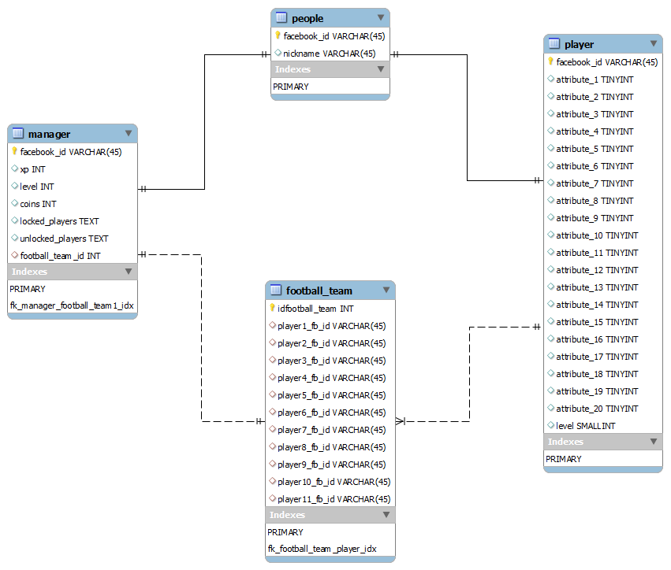
Every people in the game (player or manager) is linked to a people entry in the “people” table. It simply contains his facebook id, and a nickname, as every manager shall be able (in the future) to add a nickname to his avatar.
So, every manager will have an entry in the “manager” table, whose key is the user's facebook id. The entry contains every data useful to define the manager, including a list a locked and unlocked players in text format, which actually are JSON arrays listing facebook ids. These facebook ids will be used as keys to get the corresponding players from the “player” table. The football_team_id is a key to an entry in the “football_team” table, which contains a list of eleven players' facebook id (hopefully, Football won't change the number of players soon).
Every player has an entry in the “player” table, with 20 entries, that actually are the player's attributes, where the number of the attribute has a correspondance in the config file, associating this index to a specific attribute's name. The level is stored, but actually it could be easily calculated (it is the total of the attributes values – 1000, which is the starting amount of points distibuted to the different attributes).

Client Architecture
The client application will be mostly made in ActionScript, embeded in an HTML page, filled with some JavaScript code ti handle some specific stuffs (like some facebook API connections that would not be available in AS, or masking the Flash application when a facebook popup appears).
Here we will only discuss the Flash application architecture, as the JavaScript nissues will be resolved when they will appear.

1. MVC
The Flash application as always will simply follow a MVC architecture, with a MainController, a MainModel connected to specific models, some views with specific Controllers, and Proxies to communicate with different servers.
To make it quick and simple, we will only list the classes included in this architecture, as the role of each class is pretty obvious (at least for me, but being the only developper, it doesn't really matter):
- MainController
- MainModel
- Views:
  - TeamBuildingView, associated with a TeamBuildingViewModel
  - PlayerPopupView, associated with a PlayerPopupViewModel
  - [(N/A in V0) ManagerHudView, associated with a ManagerHudViewModel]
  - ChallengePopupView, associated with a ChallengePopupViewModel
  - MatchResultPopupView associated with a MatchResultPopupViewModel
  - LoadingScreenView
  - LoadingPopupView
- ViewControllers:
  - TeamBuildingController, controlling the TeamBuildingView
  - PopupController, controlling PlayerPopupView, ChallengePopupView and MatchResultPopupView
  - [(N/A in V0) HudController, controlling the ManagerHudView]
  - LoadingController, controlling the LodaingScreenView and the LoadingPopupView
- Models:
  - ManagerModel
  - PlayerModel
  - TeamModel, which is the mother-class of sport specific TeamModel (for example FootballTeamModel)
  - UserModel
- Proxies:
  - FacebookProxy
  - WebServerProxy

